S550 Track Apps Start Option Control Function – CGEA1.3

Functional Description

Start Option lets the user select from one of the pre-configured options to run one of the available Track App features.

Selection Options:
Automatic Start: When selected, the data collection begins as soon as the cluster senses that vehicle has started moving.
Drag Start: When selected, the user is taken thru instructions on getting ready for a F-1 style start.
Countdown Start: When selected, the user is taken thru instruction on getting ready for a “Pro-Race Tree” style start.

The Wrong Way Alert warning correlates the M/C Switch Event and the Operational_mode to process the Start Option selection via the cluster Track App Setting menu.

Interfaces

Interface Context Diagram (I/O Block Diagram)

Figure 1 Track Apps Start Option Control Function Context Diagram
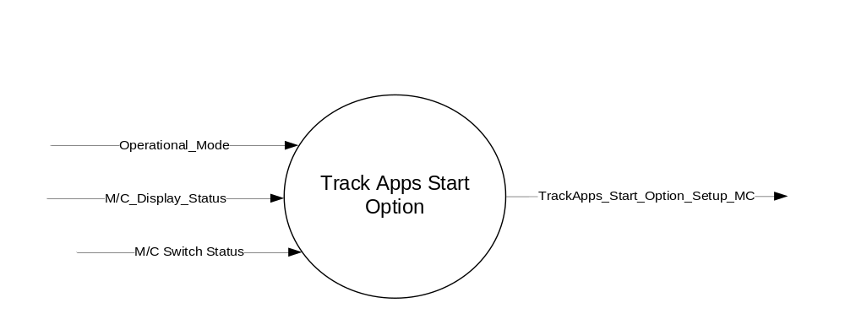

Inputs
      - INTERNAL:
    - Operational_Mode
    - M/C Switch Event
    - M/C_Display_Status

Outputs

TarckApps_Start_Option_Setup_MC, used to save and display the current status of user setting.

Function/Performance

Operational Modes

Mode | Differentiating Vehicle Conditions
Sleep Mode | Track Apps Start Option Function Disabled
Limited Mode | Track Apps Start Option Function Disabled
Normal Mode | Track Apps Start Option Set up Allowed
Crank Mode | Track Apps Start Option Set up Allowed

Voltage Levels

Refer to the Cluster Features Table located in the Operational Modes and Voltage Range Strategies Section of this SPSS

Human-Machine Interface

Visual

1.3.3.1.1 Indicator Graphics / Display Format
Please refer to specific cluster menu structure for accurate graphics.
Example Graphics:
Start Option > | t#$ | Start Option
 |  | # Automatic Start
 |  | # Drag Start
 |  | # Countdown Start

1.3.3.1.2 Indicator Color Coordinates

Reference section COLOR & ILLUMINATION REQUIREMENTS (GRAPHICS).

Audio

None.

Switch Control Logic

None.

System Accuracy

Within 100 msec of receiving a message that results in a change of state the cluster will update the output flag to the proper state.

Operation: Performance and Functional

Subsystem Algorithm Flowchart / State Diagram

Figure 2: Track Apps Start Option Process Flowchart
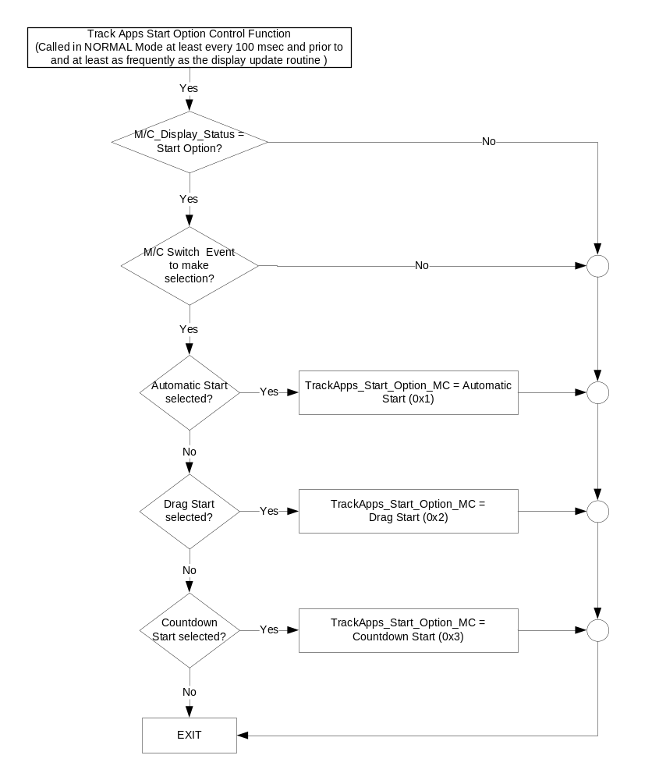

Operation Description (supports algorithm flowchart /state diagram)

Function Safety Classification (EMC)

Class B

Memory Storage
Parameter Name | Description | Value at  Battery Connect | Value at  Module Wake-up
TrackApps_Start_Option_Setup_MC | Output variable that displays and saves the user selected start option. | Automatic Start (0x1) | Use stored value
M/C_Display_Status | State Indicator to identify which text is currently being displayed on Message Center display. See * | See * | See*
M/C Switch Event | Event that is indicated as per the switch interface for the Message Center. See * | See * | See*
Operational_Mode | 4 state indicator for cluster operational mode | Limited | Limited, Normal or Crank
* Refer to Message Center X Display_Y Button Interface Section, where X and Y are appropriate values in this document.

Prove Out

No.

Reconfigurable Telltale

No.

Message Center Msg

No

Error Handling

Missing Message Strategy

Not Applicable

Diagnostics

Self Test

None

Engineering Test Mode

Not Applicable

Part II Performance

None

Reference Specification

IS-0052 OPERATING VOLTAGES - FUNCTIONAL/PERFORMANCE
IS-0069 FUNCTIONAL IMPORTANCE CLASS
IS-0324 WINDSHIELD & OTHER REFLECTIONS

IL-0023 CLARITY/LEGIBILITY/READABILITY/VISUAL CONTRAST
IL -0045 COLOR
IL -0048 ILLUMINATION ACCEPTABILITY

03-0661 PLACEMENT: CONTROL AND DISPLAY LOCATIONS
03-0662 PLACEMENT: LOGICAL GROUPING FUNCTION AND USAGE
03-0665 PLACEMENT: EXPECTED LOCATIONS OF CONTROLS AND DISPLAYS VDS
03-0670 INTERIOR VISIBILITY
03-0671 INTERIOR VISIBILITY: REFLECTIONS FROM COMPONENTS & SURFACES
03-0672 INTERIOR VISIBILITY: REFLECTIONS IN DISPLAYS
03-0673 INTERIOR VISIBILITY: VISUAL OBSCURATIONS
03-0674 INTERIOR VISIBILITY: ILLUMINATION CONTROLS / DISPLAYS
03-0675 INTERIOR VISIBILITY: VEILING GLARE
03-0677 INTERIOR VISIBILITY: SUNLIGHT WASHOUT
03-0681 IDENTIFICATION: CHARACTER AND SYMBOL SIZE
03-0682 IDENTIFICATION: LEGIBILITY
03-0685 IDENTIFICATION: SYMBOLS, ABBREV FOR CONTROL
03-0721 LOGIC OF OPERATION: OPERATIONAL STEREOTYPES
03-0722 LOGIC OF OPERATION: INTERPRETATION
03-0723 LOGIC OF OPERATION: USE OF SYSTEMS WITH VISUAL DISPLAYS

Revision History
SPSS Module Revision History

Revision  Level | Name | Change Description | Date
1.0 | V. Patel | Initial release for 2018+ S550 cluster | 02/26//2016

